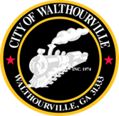
City of Walthourville
Mayor and Council Workshop Agenda
September 24, 2024 @ 5:00 PM
Walthourville Police Department

AGENDA

- Call to Order Mayor Sarah B. Hayes

- Roll Call City of Walthourville

- Cost Reduction Councilmembers

- Adjournment Councilmembers

This meeting is open to the public.

