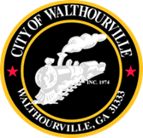
City of Walthourville
FY 2027 Budget Workshop # 1
August 17, 2026 @ 6:00 PM
Walthourville Police Department

AGENDA

- Call to Order Mayor Sarah B. Hayes
- Roll Call City of Walthourville
- FY Budget 2027 CKH, Mayor and Council
- Adjournment Councilmembers

