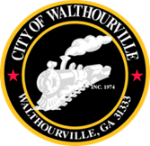
CITY OF WALTHOURVILLE

FY 2026 BUDGET WORKSHOP # 5

December 2, 2025 @ 6:00 PM
Walthourville Police Department

AMENDED AGENDA as of 12-01-2025

AMENDED AGENDA

I. Call to Order Mayor Sarah B. Hayes

II. Roll Call City of Walthourville

III. Insured Georgia Marketplace Presentation Ms. Melissa Camp

IV. FY 2026 Budget Discussion CKH, Mayor and Council

V. Adjournment Councilmembers

This meeting is open to the public.

