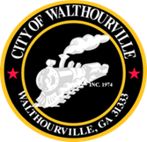
City of Walthourville
FY 2025 Budget Public Hearing
December 19, 2024
6:00 PM-Walthourville Police Department

AGENDA

The Honorable Mayor Sarah B. Hayes, Presiding

- Call to Order Mayor Sarah B. Hayes
- Roll Call for Elected Officials City Clerk
- Motion to Enter Public Hearing Councilmembers
- Public Hearing
- Motion to Close Public Hearing Councilmembers
- Adjournment Councilmembers

