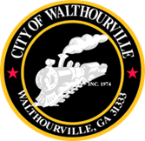
City of Walthourville
Charter Update Meeting

March 18, 2026 @ 6:00 PM
Walthourville Police Department

The Mayor and Council of the City of Walthourville will meet on March 18, 2026, at 6:00 PM for a Charter Update Meeting.

AGENDA

I. Call to Order Mayor Sarah B. Hayes

II. Roll Call City of Walthourville

III. Charter Updates/Discussions Mayor and Council

IV. Adjournment Councilmembers

This meeting is open to the public.

