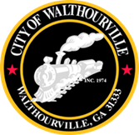
City of Walthourville
Mayor and Council Special Called Meeting
March 4, 2024 @ 5:00 PM
Walthourville Police Department

The Honorable Mayor Sarah B. Hayes, Presiding

- Call to Order Mayor Sarah B. Hayes
- Roll Call City Clerk
- Invocation Appointee
- Pledge of Allegiance In Unison
- Millage Rate Mayor and Council
- Adjournment Mayor and Council

