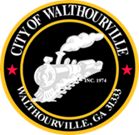

FY 2025 Budget Adoption Special Called Meeting
December 27, 2024 @ 12 Noon
Walthourville Police Department

AGENDA

- Call to Order Mayor Sarah B. Hayes

- Roll Call for Elected Officials City Clerk

- Purpose of Meeting Mayor Sarah B. Hayes
The Budget for the General Fund is $2,736,468.26 and the Water Fund Budget is $2,630,100.00.

- Motion to Approve FY 2025 Budget Mayor and Council

- Motion to Adjourn Councilmembers

