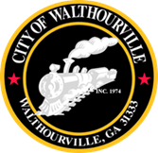
City of Walthourville

Public Hearing # 1 FLOST
August 7, 2025 @ 6:00 PM
Walthourville Police Department

AGENDA

I. Call to Order Mayor Sarah B. Hayes

II. Roll Call City of Walthourville

III. Public Hearing Citizens & Elected Officials

IV. Adjournment Councilmembers

