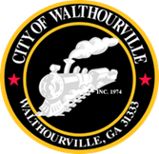
City of Walthourville
Millage Rate Meeting
October 3, 2024 @ 6:00 PM
Walthourville Police Department

AGENDA

I. Call to Order Mayor Sarah B. Hayes
II. Roll Call City Clerk
III. Millage Rate Mayor, Council & CKH, Consulting
IV. Adjournment Councilmembers

*CHH Consulting will be virtual.
**This meeting is open to the public.

