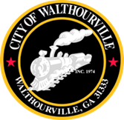
City of Walthourville
Mayor and Council Workshop Meeting
March 14, 2024 @ 6:00 PM
Walthourville Police Department Council Chamber

The Honorable Mayor Sarah B. Hayes, Presiding

AGENDA

- Call to Order Mayor Sarah B. Hayes

- City Discussions Mayor and Council

- Adjournment Council

*This meeting/workshop is discussion only, no action and votes will be taken.

